Morgan Hill Open Studios (MHOS) Code of Conduct
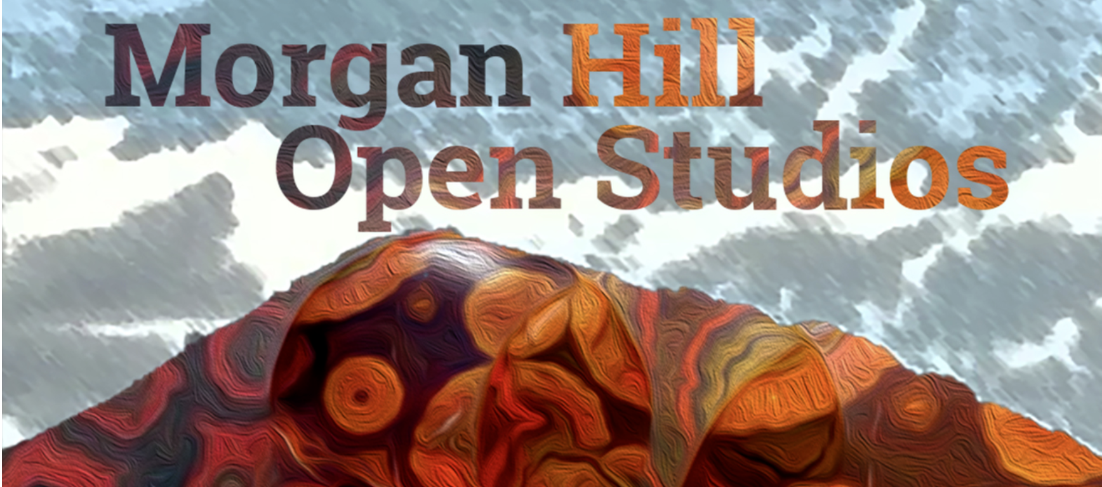

- PURPOSE
We believe our community should be truly open to everyone. As such, we are committed to providing a friendly, safe and welcoming environment for all, regardless of gender, sexual orientation, disability, ethnicity, or religion.
This code of conduct outlines our expectations for exhibitor and participant behavior, as well as the consequences for unacceptable behavior. We invite exhibitors and other participants to help us realize a safe and positive MHOS experience for everyone.
By participating at the event, you agree to abide by the MHOS Code of Conduct

2. EXPECTED BEHAVIOR
- Be considerate, respectful, and collaborative.
- Refrain from demeaning, discriminatory or harassing behavior, materials and speech.
- Be mindful of your surroundings and of your fellow participants. Alert event organizers if you notice a dangerous situation or someone in distress.

3. UNACCEPTABLE BEHAVIOR
- Unacceptable behaviors & materials include intimidating, harassing, abusive, discriminatory, derogatory, or demeaning materials or conduct by any exhibitors or attendees of the event and related event activities. Some event venues are shared with members of the public; please be respectful to all patrons of these locations.
- Harassment includes: offensive comments (verbal, written, or otherwise) related to gender, sexual orientation, race, religion, disability; deliberate intimidation, stalking or following; harassing materials, photography or recording; sustained disruption of talks or other events (whether verbal or otherwise); inappropriate physical contact, and unwelcome sexual attention.
- Wearing clothing that is not suitable for a public environment, or otherwise potentially offensive.
- Physical, written, verbal or other abuse, intimidation, threats, annoyance, harassment, stalking, pushing, shoving or use of any physical force whatsoever against any person, which in any way creates a disturbance that is disruptive or dangerous, or creates apprehension in a person.
- Possession of any item that can be used as a weapon, which may cause danger to others if used in a certain manner.
- Any boisterous, lewd or offensive behavior or language, including but not limited to using sexually explicit or offensive language, materials or conduct, or any language, behavior or content that contains profanity, obscene gestures, or racial, religious or ethnic slurs,
- Possessing any illegal substance, including but not limited to narcotics or other illegal drugs
- Assembling for the purpose of, or resulting in, disturbing the peace, or committing any unlawful act or engaging in any offensive behavior.
- Failure to obey any rules or regulations of all shared spaces and venues.

4. CONSEQUENCES OF UNACCEPTABLE BEHAVIOR
Unacceptable behavior will not be tolerated whether by exhibitors, attendees, media, speakers, volunteers, organizers, venue staff, sponsors, or exhibitors. Anyone asked to stop unacceptable behavior is expected to comply immediately. If a participant engages in unacceptable behavior, the MHOS organizers may take any action they deem appropriate, up to and including expulsion from the MHOS event without warning or refund, and informing authorities.

